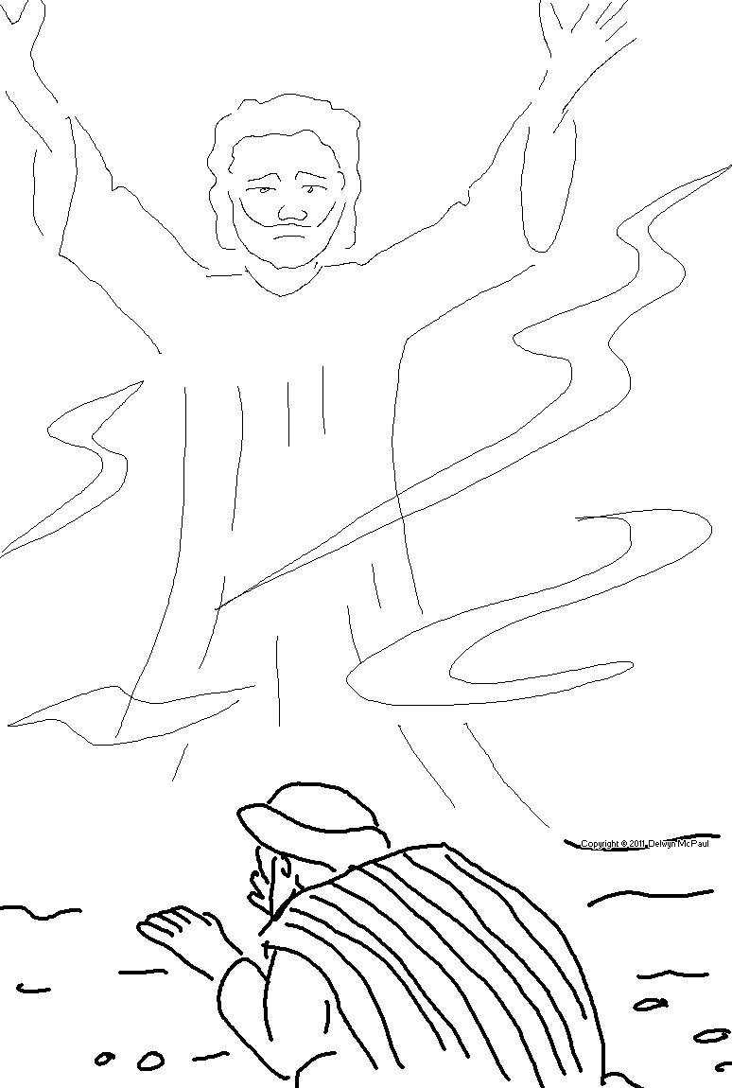
The dead know nothing.
Ecclesiastes 9:5 _{NLT}

